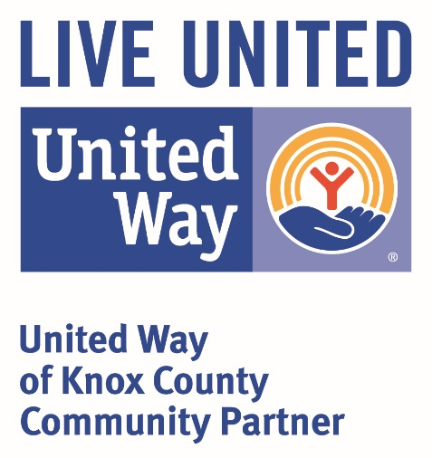

**Annual Granting / Community Investment**

**Process Overview**

* **Step One:** Request To Apply April 1st - June 1st *(if granted approval to apply – move to step two)*
* **Step Two:** Application – Due December 1st
* **Step Three:** Community Investment Process – Applicants notified by March 1
* **Step Four:** Fund Distribution – Qtrly Payments (April, July, October & December)
* **Step Five:** Annual Report – Due December 1st

**Step One: Request To Apply (RTA)**

A Request To Apply is filed each year between April 1st and June 1st for the following year grant cycle. ***(Example: For funding in 2016 – RTA’s are accepted beginning April 1, 2015 and are due to UWKC by June 1, 2015)*** The opening to accept RTA’s will be announced via several media sources. Your agency is responsible for initiating the RTA. If you miss a filing deadline, your agency will have to wait for the next open acceptance period the following year. Approval is based upon the annual funding priorities of the UWKC which align with the specific needs of the Knox County community for the applicable grant year. You will be notified of the approval or denial of your RTA.

***Why RTA?*** The Request to Apply allows UWKC to identify the organizations and programs that will request funding prior to entering into our annual campaign each year. Prior knowledge will allow UWKC to set goals, promote agencies *(in both written and verbal marketing)*, and enable committee members to improve upon due diligence by personally familiarizing themselves with the organizations with which the UWKC partners. Prioritization of annual community investments depend on input from community members, contributors, and volunteers affirming the value our community places on these issues.

**Step Two: Application Process**

Once your agency has received notification they are approved to file a grant application, you will receive the current grant application and be notified of the application deadline. This deadline may vary from year to year for different reasons. Make sure your agency is aware of the current filing deadline.

**Step Three: Community Investment Process**

Once grant applications are received, they will be distributed to committee members. It is necessary for our committee to wait for finalization of the year-end financial records to determine the total amount allowable for community investment.

**Step Four: Fund Distribution Process**

Partner Agency funds are distributed quarterly. You will receive funding checks at the Quarterly Agency Meetings. You are not required, but encouraged, to attend Quarterly Agency Meetings. If you, or a representative is unable to attend, your allocation check will be mailed.

***Why are funds distributed quarterly?***

Quarterly distribution of annual funds allow for budgetary and cash-flow safe regulations for your agency and UWKC. Pledges received the prior year during campaign are being collected during the funding year.

***What are Quarterly Agency Meetings?***

Meetings hosted by UWKC for the benefit and collaboration of all of our partners. They are usually held around the 15th of the month (April, July, October & December). Lunch is provided at no charge. Collaboration is crucial to the work we all conduct in the community. The meetings are a great way to network with other agencies, learn information as it applies to the health and human services programs (from internal and external speakers), and connect with UWKC to make sure you have the latest information from this funding source.

**Step Five: Annual Report**

All funded partners are required to file an annual report with UWKC. This document is due by December 1st *(subject to change – please be informed of current due date)*. Annual reports are reviewed by committee prior to establishing funding levels for the year. As good stewards of the funds entrusted to us by our donors, it is essential that we review how previous funding was utilized, within the parameters of your request, prior to granting future funding.

**For additional questions, please contact:**

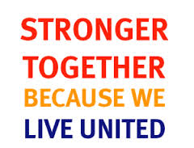Kaleena McCormick, Community Impact Assistant

[communityimpact@unitedwayofknoxcounty.org](mailto:communityimpact@unitedwayofknoxcounty.org)

Angie Goff, Executive Director

[agoff@unitedwayofknoxcounty.org](mailto:agoff@unitedwayofknoxcounty.org)

Or by calling our office: 812-882-3624