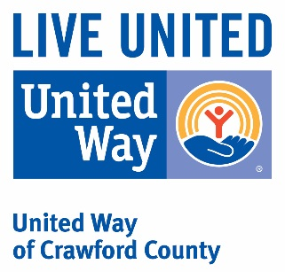 ***2021 Grant Year***

***Forward Preview***

*Disclaimer: To receive funds, agencies must qualify as tax exempt under federal law, be a 501c3 in the State of Illinois, be a health and/or human services organization, meet financial reporting requirements (as requested by the UWCC grant application), and comply with provisions for Anti-Discrimination and Anti-Terrorism Compliance Measures.*

***What is a “health or human service agency”?***

One whose principal objective is to improve conditions necessary to achieve fundamental physical, social and/or psychological well-being. We fund health and human service programs of agencies where community impact is clear and defined.

***Does your agency provide multi-county services?***

We fund agency programs that offer specific services for which the community impact can clearly be identified rather than provide general funding. For multi-county agencies, the budget submitted with this application should reflect only program services to be provided in Crawford County.

***What are the funding priorities of United Way of Crawford County for 2021?***

Our four priorities are: Crisis Assistance; Education; Health; & Income *(through financial stability engagement).* ***We are also making continued strides in developing Impact work in the community that is cross agency and focused on more long term outcomes.*** Due to limited funds for allocation, requests for personnel, overhead, and capital expenditures such as equipment, vehicles and facility purchases or renovation are discouraged. Applicants should note that funding resources vary from year to year. As the reasons behind the donations change and evolve, so too will the allocating focus of the United Way of Crawford County. It has been noted many times but bears repeating in print, funding from year to year is *not guaranteed*. Each funding year is exclusive, and so are the allocation amounts determined each year.

**Evaluation & Allocation Determination Criteria**

When applying please consider the Allocations Committee will use the following criteria for reviewing and allocating requests:

**COMMUNITY NEED**

* Does the program address a health and human service need in our community?
* What is the severity of the problem to be addressed?

**IMPACT**

* How well does the program demonstrate a meaningful linkage between community needs, program activities, and outcomes?
* Will the program provide a meaningful volume of services and/or people served?

**PROGRAM REPORTING**

* Are clear goals and objectives written?
* Are measurable outcomes evident?
* How well does the agency/program demonstrate the ability to deliver and measure proposed outcomes?

**FINANCIAL MANAGEMENT**

* Does the program have a reasonable budget?
* Is other funding available/applied for/obtained?
* Will funds requested from UWCC support direct program services?

**RELATIONSHIP** *(For Previously Funded/Reapplying Agencies)*

* Does the agency engage in a year round commitment and partnership with UWCC?
* Did the agency accomplish its goal and objectives from previous funding requests?
* Did the agency make an impact with previous funds allocated by UWCC?
* Does the agency participate in UWCC campaign and year round activities?
* Does the agency participate in community collaboration efforts with other agencies and organizations *(not specifically UWCC partner agencies)*?

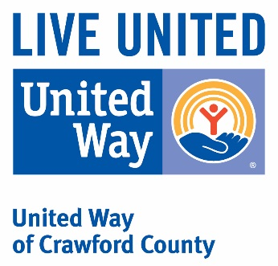 **Grant Application**

***2021 Grant Year***

***(Due December 01, 2020)***

**Requesting Organization:**

Reapplying Agency/Organization

* New Agency/Organization Request
* Designation Only Request

**Program Title:**

**Contact Name:**

**Contact Phone and Email:**

**Funding Amount Requested:**

**Community Impact Area – Choose Only One Impact Area**

**Crisis Assistance**- responding to the immediate needs of individuals as they apply to food, clothing, and/or shelter.

* **Education** - helping children, youth, and/or adults achieve their potential. Education is essential to obtaining and retaining a job with a self-sustaining, livable wage and health benefits.
* **Income** - promoting financial stability and independence. Reducing the potential for, or helping to illuminate the need for governmental assistance to sustain one’s livelihood.
* **Health**- improving the health of individuals. Healthy lifestyles and access to quality health care keep children on track in school and adults independent and productive.

**Program Specific Overview**

Describe the community’s need for the program and how the target population served is helped:

Describe your program accessibility – Is it accessible to all Crawford County community members or does it target a specific neighborhood or population?

Describe the number of individuals the program expects to serve and if the program is free or free-based:

*Pg. 2 Application*

*Organization Name:*

**Program Specific Overview *(continued)***

Is your agency/organization successfully fulfilling its mission/objective in Crawford County? Please explain:

Provide knowledge on how your organization’s program does not duplicate a similar service being provided by another community organization. If it does, explain how your program differs from similar services provided by other organizations or collaborates with those agencies: Our program is the only one of its kind in Palestine’s school district.

List the program goals and identify the most impactful objectives that can be realized within the reporting timeframe: Continue to feed hungry students, allowing them to function to their full capacity.

Describe the strategies of your program implementation process:

Explain how the objectives will be measured and outcomes are expected to be produced:

Are there any obstacles that may affect your ability to achieve your mission?

How many staff and volunteers support this program?

Please share success stories related to this program, (previous successes if this is a new request), that pertain to Crawford County:

**Community Collaboration**

Is your program in a collaborative effort? No – we are a standalone program.

*If yes, please answer the following:*

With what other community organizations do you partner to implement this program? Who and in what capacity?

Describe how partnerships improve the efficiency and effectiveness of this program, and list any shared resources:

** Program Budget Summary**

***2021 Grant Year***

**Organization:**

**Program:**

**Funding Amount Requested:**

**Organization Annual Budget**  $

**Total Program Budget**  $

**Program Budget Breakdown**

Expense: Amount

Explain:

***(Add additional explanations if needed)***

*Pg. 2 Financial Summary*

*Organization:*

**Program Funding Questions**

Does your program have a minimum funding requirement? No

*Please Note: Answering no, United Way of Crawford County will assume your program will exist and you will follow reporting requirements no matter the funding level provided by UWCC. Answering “yes” to this question means that your organization cannot accept anything below the amount requested. If UWCC is not able to fund your program at the minimum level requested, your program will not exist unless another funding source is located. Careful thought should be given to the minimum, as it will be relied upon by the Allocations Committee when deciding funding.* ***If a minimum is listed, and it cannot be met by the committee, it will result in no funding to your program.***

If yes, please list the amount $

If no, describe the overall program impact and how you will sustain the program effort if UWCC funding is reduced or eliminated:

**Additional Funding Questions**

Do you utilize grants to leverage the program funding?

Identify other major funding sources: Our fundraisers (which have included bake sales, softball games, paint party & raffle baskets).

Have you had any, or do you project any, significant changes in your operating budget? If so, please explain:

If funding at any level is received from UWCC, the applying agency agrees to comply with annual reporting requirements:

YES

* NO

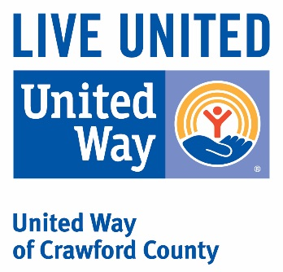

***Anti-Terrorism Compliance Measures Policy***

In compliance with the *US PATRIOT ACT* and other counterterrorism laws, the United Way of Crawford County requires that each agency/organization *(entity bearing the 501c3)* certify the following:

I hereby certify on behalf (A*gency/organization)*

That all United Way funds and donations will be used in compliance with all applicable anti-terrorist financing and asset control laws, statutes and executive orders.

Please mark either “YES” or “NO” in the space below. By marking “YES”, the Executive Director attests to the member agency’s compliance with the United Way’s counterterrorism mandate above.

YES

* NO

Signature Date

Mary Michael Secretary/Treasurer

Printed Name Title



**Standards of Operation**

***2021 Grant Year***

***If you answer “no” to any of the following questions,***

***Please provide a simple explanation as to why.***

Is your organization recognized as exempt from taxation under 501(c)3 of the Interanl Revenue Code? Yes

Does your organization file an IRS 990 annually, and in a timely manner? Yes

Does your organization have an active, responsible, and voluntary governing body which ensures effective governance over the policies and financial resources of the organization? Yes

Does the board approve an annual budget? no

Does the board (or finance committee) review the financial statements regulary? yes

If yes, how often? Montly

Does your organziation operate within the guidelines of your by-laws and constitution? yes

Are programs or initiatives of your organization based on your mission statement? yes

Does your organization adhere to an adopted code of ethics for volunteers and staff? yes

Does all staff annually verify, in writing, they have reviewed the code of ethics? no

Are volunteers and staff required to sign a Conflict of Interest Disclosure Statement annually? no

Does your organization have an annual audit conducted by an independent certified public accountant? no

If no to the question above - Does your organization have its financial statements reviewed by an independent public accountant? No-but could implement this if needed

Is the audit presented for your full board to review and approve?



**Grant Application Submission Agreement**

***2021 Grant Year***

**Organization Name:**

**Amount Requested**

**Program Name:**

**Contact Name:**

**Contact Phone and Email:**

I acknowledge agency is requesting funding from United Way of Crawford County for the 2018 Grant Year. By signing below, we acknowledge our organzation/agency is willing to comply with the terms and conditions established within the application set forth by United Way of Crawford County.

__________________________ ____________________

Signature Date

**Grant Application - Supporting Documentation**

***2021 Grant Year***

***Before submitting application for review***

***Please make sure all information is complete.***

**Organization Name:**

**Program Name:**

***REQUIRED DOCUMENTATION FOR CONSIDERED APPLICATIONS***

Completed Grant Application

Completed Program Budget Summary

Signed Anti-Terrorism Compliance Measures Policy

Standards of Operation

Signed Grant Submission Acknowledgement

***Supporting Documentation***

* List of Board Members Contact Information
* Applying Agency’s Non-Discrimination Policy
* Applying Agency’s Code of Ethics Policy
* Copy of last filed 990
* Copy of 501c3 *(for new applying organizations/agencies -OR- Organizations who obtained their own 501c3)*

**For Organizations/Agencies with annual budgets of $10,000+**

* Copy of Auditor’s/CPA’s final summary/overview from your last audit – must include date, signature and contact information for the auditing member
* Notarized Certification of Crime Insurance Coverage (fka: bonding insurance)

**IMPORTANT:**

Please provide United Way of Crawford County with ***ONE, ORIGINAL Copy***, of all of the required documentation – ***SINGLE SIDE ONLY*** – no staples please – by the filing date and time indicated below.

***FILING DEADLINE FOR GRANT APPLICATION & ANNUAL REPORT***

***December 1, 2020 by 12:00 pm***